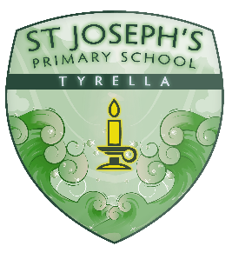
St Joseph’ Primary School
Tyrella

Food Allergy Policy
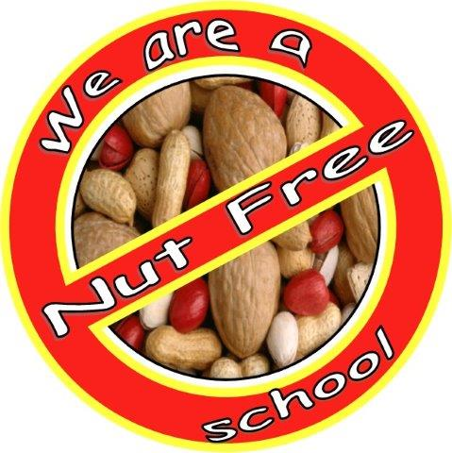

St Joseph’s PS aims to practice a nut free policy although we recognise that this cannot be guaranteed . This policy serves to set out all measures to reduce the risk to those children and adults who may suffer an anaphylactic reaction if exposed to nuts or other foods to which they are sensitive. The school aims to protect children who have allergies to nuts and other foods yet also help them , as they grow up , to take responsibility as to what foods they can eat and to be aware of where they may be put at risk.

Definition
Anaphylaxis ( also known as anaphylactic shock)is an allergic condition that can be severe and potentially fatal. It is your body’s immune system reacting badly to substance ( an allergen) , such as food, which it wrongly perceives as a threat. The whole body can be affected , usually within minutes within contact with an allergen. Sometimes the reaction can happen hours later.
This policy refers primarily to nuts but also includes sesame seeds, pine kernels, coconut and sunflower seeds etc.. as required.

Symptoms
The symptoms of anaphylaxis usually start between 3 and 60 minutes after contact. Less commonly , they can occur a few hours or even days after contact.
An anaphylactic reaction may lead to feeling unwell or dizzy or may cause fainting due to a sudden drop in blood pressure. Narrowing of the airways can also occur at the same time with or without the drop in blood pressure. This can cause breathing difficulties and wheezing.
Other symptoms include :
- Swollen eyes , lips , genitals, hands, feet and other areas
- Itching
- Metallic taste in the mouth
- Sore red itchy eyes
- Change of heart rate
- Sudden anxiety / apprehension
- Itchy skin or nettle rash
- Unconsciousness
- Abdominal cramps
- Vomiting / diarrhoea
- Nausea / fever
Anaphylaxis varies in severity. Sometimes it causes only mild itches and swelling , but in some people it can cause sudden death. Anaphylaxis can lead to death if breathing becomes severely obstructed or the blood pressure becomes extremely low ( known as shock).
If symptoms start soon after contact with the allergen and rapidly get worse , this indicates that the reaction is more severe.

Staff
The onus falls on all staff to read and follow this policy both in school and when out on trips.
Caution must be taken at certain times of year such as Easter and Christmas. If staff has sweets in the class care must be taken to ensure that no nuts etc… are included in the product. This includes the warning on packaging that “ it may contain nuts or that it has been manufactured in an area where there may have been products containing nuts “. Fruit sweets such as Haribos are a better alternative. Particular products that are a cause for concern are :
- Celebrations
- Roses
- Heroes
- Quality Street

All product packaging must be checked for warnings directed at nut allergy sufferers and if the following or similar are displayed , the product must not be used in school without supervision of staff and supervised handwashing :
Not suitable for nut allergy sufferers
This product contains nuts
This product may have been manufactured in an area where there may have been products containing nuts .

Parents
We ask parents not to bring in any food or treats ( ie. For birthdays ) unless they have checked the ingredients carefully. Packaging must be checked for :
- Not suitable for nut allergy sufferers
- This product contains nuts
- This product may have been manufactured in an area where there may have been products containing nuts .
Indicating this is not suitable for school consumption.

Children
All children are regularly reminded about the good hygiene practice of washing hands before and after eating which helps to reduce the risk of secondary contamination.

Review
This policy will be reviewed regularly.

